Supplementary file

A combined microfluidic deep learning approach for lung cancer cell high throughput screening toward automatic cancer screening applications
Hadi Hashemzadeh ^{1, †}, Seyedehsamaneh Shojaeilangari ^{*, 2, †}, Abdollah Allahverdi ³, Mario Rothbauer ^{4, 5}, Peter Ertl ^{*, 5}, Hossein Naderi-Manesh ^{*, 1, 3}
¹ Nanobiotechnology Department, Faculty of Biosciences, Tarbiat Modares University, Tehran, Iran
² Biomedical Engineering Group, Department of Electrical Engineering and Information Technology, Iranian Research Organization for Science and Technology (IROST), P.O. Box 33535111, Tehran, Iran
³ Biophysics department, Faculty of Biosciences, Tarbiat Modares University, Tehran, Iran
⁴ Karl Chiari Lab for Orthopaedic Biology, Department of Orthopedics and Trauma Surgery, Medical University of Vienna, Währinger Gürtel 18-22, 1090 Vienna, Austria
⁵ Institute of Applied Synthetic Chemistry and Institute of Chemical Technologies and Analytics, Faculty of Technical Chemistry, Vienna University of Technology, Getreidemarkt 9/163-164, 1060 Vienna, Austria
* Correspondence: s.shojaie@irost.ir (S.Sh.); Naderman@modares.ac.ir (H.N-M.); Peter.ertl@ tuwien.ac.at (P.E.)
† These authors contributed equally to this work.

Supplementary Method
The primary steps of the data processing pipeline are illustrated in Figure S1.​ Given that the raw images are substantial in size, approximately 10,000 x 10,000 pixels, we partitioned the images into smaller patches to reduce the computational load for subsequent processing. Furthermore, to further decrease the computational cost associated with model training, we converted the patches from RGB to grayscale. Subsequently, we applied transfer learning techniques using five different pre-trained models and ultimately conducted evaluations of the models.

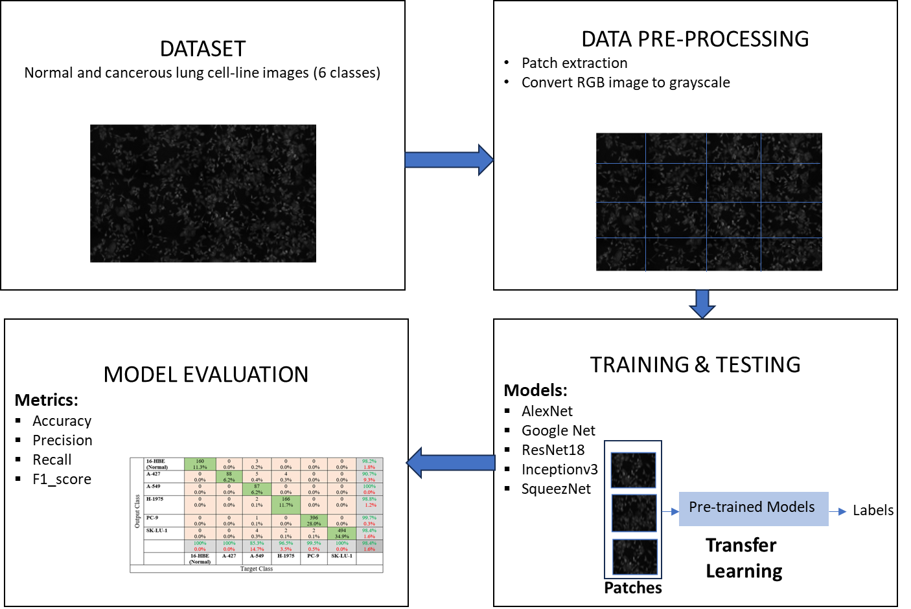
Figure S1: Main steps of the data processing

Supplementary experimental setup
Strategy to Address Class Imbalance
In machine learning, class imbalance occurs when the distribution of classes in the dataset is unbalance, leading to poor model performance on underrepresented classes. This problem is common in various fields, such as fraud detection, medical diagnoses, and anomaly detection. As explained in the paper to handle the problem of class imbalance data, we employed the augmentation strategy (including scaling, rotation, and translation) to equalize the sample distribution across the 6 classes. Our strategy to tackle class imbalance involves two critical steps: first, oversampling the minority class with randomized replacement and, subsequently, augmenting the training samples. This part outlines these strategies, their implications, and their effectiveness in enhancing model performance.
Oversampling the Minority Class with Randomized Replacement
The initial step in addressing class imbalance involves oversampling the minority class. Oversampling aims to increase the number of instances in the minority class to match or approach the sample size of the majority class. Randomized replacement is a flexibility-driven method where existing samples from the minority class are selected at random, with the possibility of duplication, to create a larger, more balanced dataset. This technique is particularly advantageous as it allows the model to learn more about the minority class's characteristics without needing to acquire additional data.
While oversampling can help mitigate the bias towards the majority class, it comes with potential drawbacks, particularly overfitting. Since the same minority instances can be repeated multiple times, the model may learn to overly represent these specific examples, thus failing to generalize adequately. Therefore, it is crucial to follow oversampling with additional techniques to provide further diversity and robustness in the training data.
Augmenting Training Samples
Following the oversampling stage, implementing data augmentation techniques becomes essential. Data augmentation refers to the method of creating new synthetic instances through various manipulations of existing data points. For instance, in image classification tasks, augmentations can include transformations such as rotation, translation, scaling, and flipping. By applying these techniques, models can be exposed to a richer variety of scenarios and input variations, thereby reducing the risk of overfitting.
The process of augmenting the newly enlarged minority class dataset fosters the emergence of more diverse patterns and feature representations. It combats the bias inherent in the duplicated samples created during the oversampling phase. Consequently, the model gains exposure to broader perspectives of the minority class, equipping it to recognize and correctly classify these instances more effectively. Additionally, effective data augmentation not only enhances the classification of the minority class but can also improve model performance metrics, such as recall and F1-score, which are crucial in imbalanced scenarios.
Integration of Oversampling and Augmentation
​When combined, the strategies of oversampling the minority class and subsequent data augmentation create a robust framework for addressing class imbalance.​ By initially increasing the training samples through oversampling, the representation of the minority class is elevated. Following this, data augmentation further diversifies these samples, providing the model with a comprehensive view of the minority class's characteristics. This integrated approach ensures that models effectively learn to distinguish between classes without being biased toward the majority, ultimately leading to better generalization and improved predictive accuracy.
Figures S2 and S3 illustrate the distribution of classes in the training data prior to and subsequent to the oversampling process. Notably, the total number of samples has increased to 1,481 after oversampling, which corresponds to the total count of the "SK-LU-1" class.

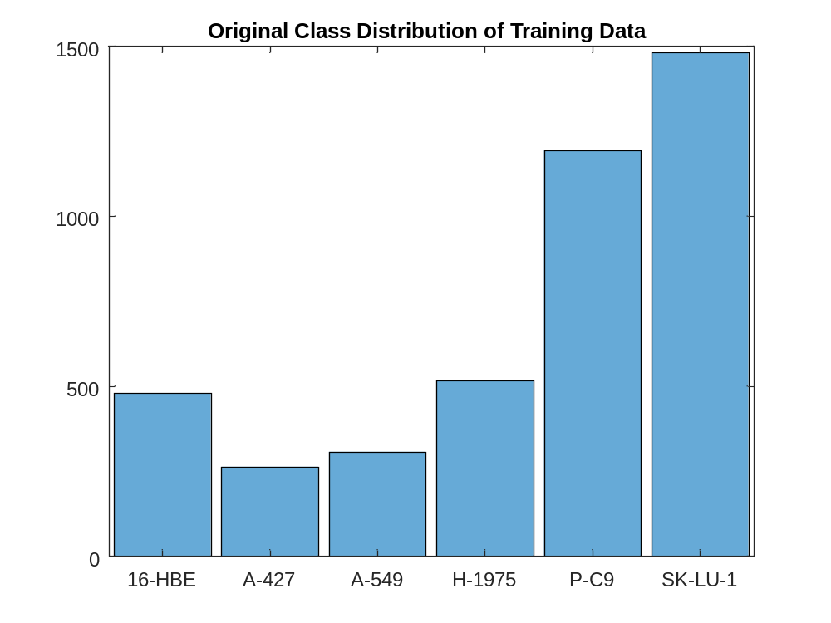
Figure S2: Class distribution of the original training data.
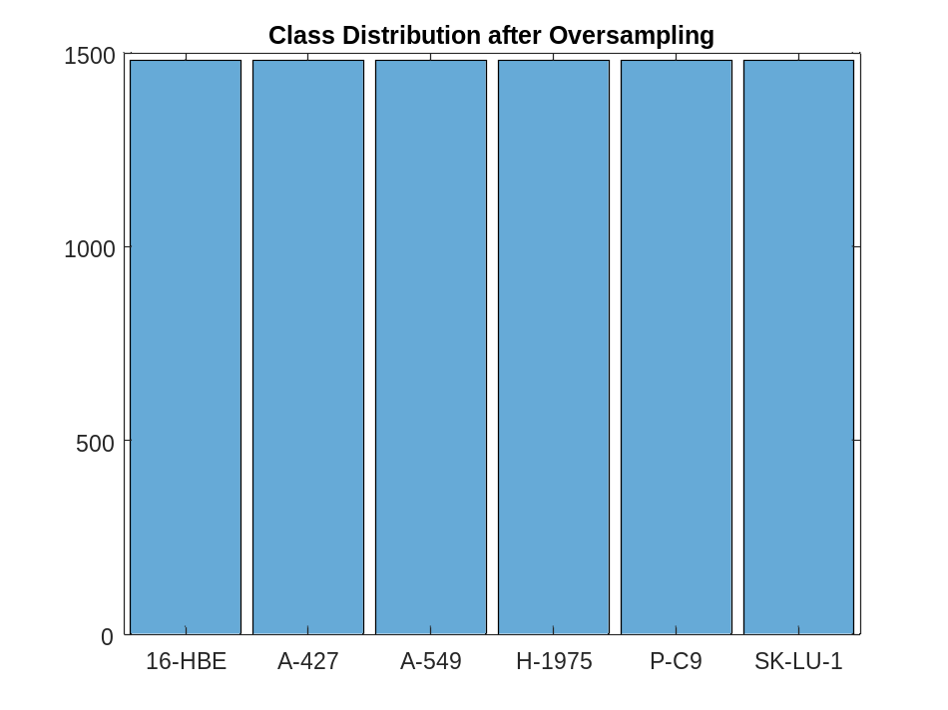
Figure S3: Class distribution of the training data after oversampling.

