Activated Biochars from Heavy Metal-Contaminated Biomass for CO₂ Capture: Adsorption Performance and Dominant Mechanisms

Nastaran Abbaspour*, Christian Jordan¹, Gregor Tondl², Patrycja Wąsik^{1,3}, Towhid Gholizadeh⁴, Daniela Tomasetig⁵, Andrzej Szlęk³, Christoph Pfeifer², Michael Harasek¹, Agnieszka Korus³, Franz Winter¹
¹ Institute of Chemical, Environmental and Bioscience Engineering, TU Wien, Vienna, Austria
² Institute for Chemical and Energy Engineering, University of Natural Resources and Life Sciences, Vienna, Austria
³ Department of Thermal Technology, Silesian University of Technology, Gliwice, Poland
⁴Department of Power Engineering and Turbomachinery, Silesian University of Technology, Gliwice, Poland
⁵ Institute of Chemical Technologies and Analytics, TU Wien, Vienna, Austria

List of contents:
S1. Raman spectrum of selected pine and birch biochar
S2. XPS survey for selected pine and birch activated biochar
S3. Pore size distributions of pine and birch biochars activated at 800 ℃
S4. Measured isotherms and model fittings for selected samples
Tables:
ST1. Content of inorganics in birch harvested from the contaminated and uncontaminated areas
ST2. Content of inorganics in pine harvested from the contaminated and uncontaminated areas
ST3. Summary of the activation tests
ST4. Adsorption kinetics parameters of CO₂ on activated pine (TP and TCP) over different temperatures
ST5. Elemental analysis of activated biochar (on a dry basis)
ST6. Content of selected inorganics in pyrolyzed and activated biochars
ST7. Pyrolyzed and/or activated biochar yield
ST8. The compositional analysis of elements (XPS)
ST9. Total (3.6 – 500 Å) volume and specific surface area of the chars as well as the volume and area of ultramicropores (3.6 – 7 Å) and supermicropores (7 – 20 Å) calculated with 2D-NLDFT method
S1. Raman spectrum of selected pine and birch biochar
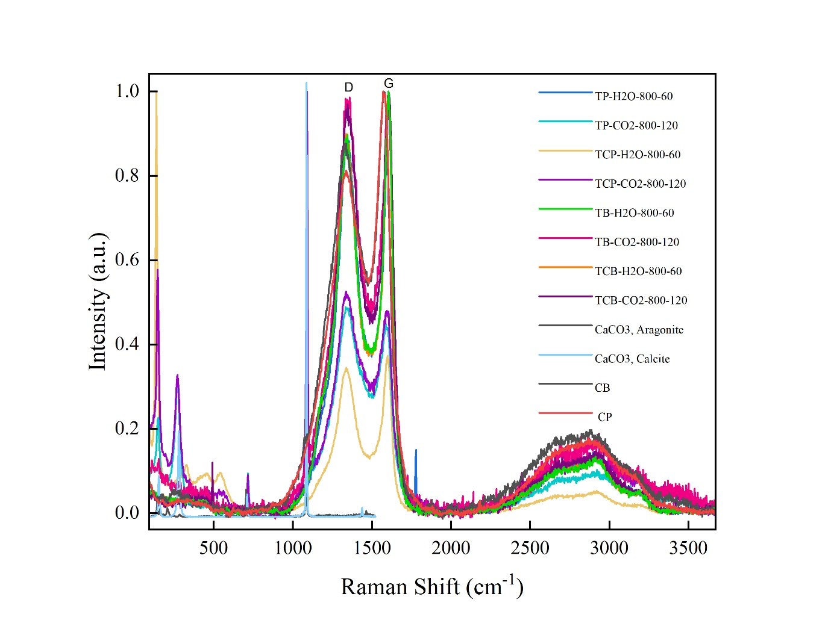
S2. XPS survey for selected pine and birch activated biochar
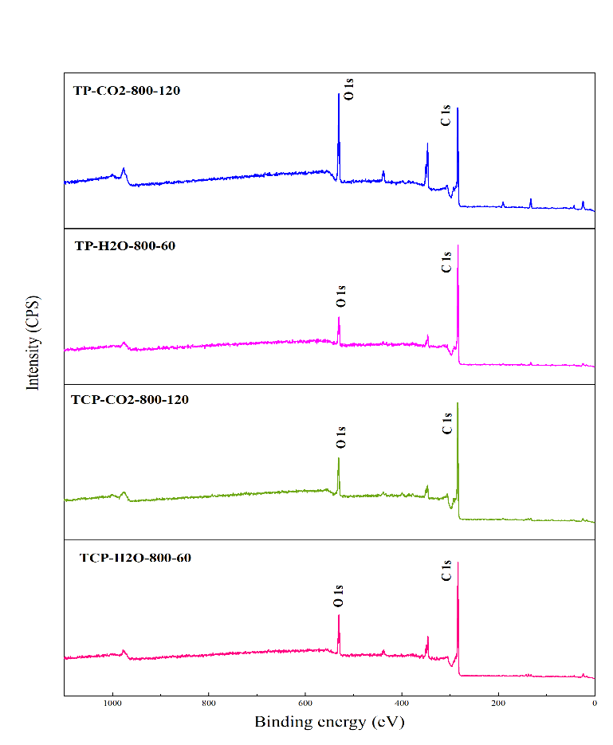
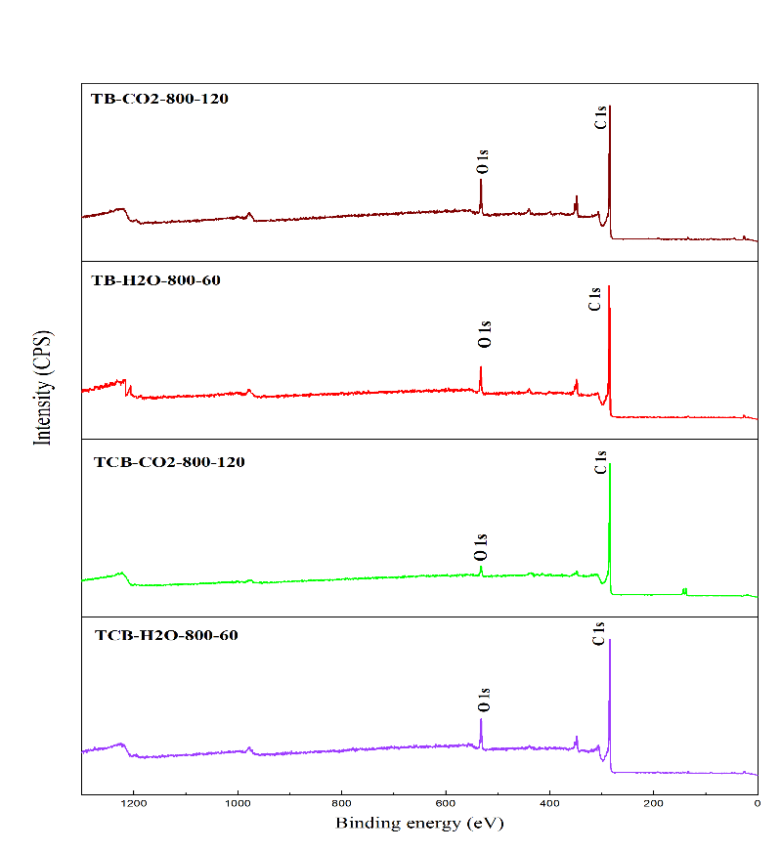
S3. Pore size distributions of pine and birch chars activated at 800 ℃

S4. Measured isotherms and model fittings for selected samples

ST1. Content of inorganics in birch harvested from the contaminated and uncontaminated areas
Elements | Contaminated Birch (mg/kg) | ± | Uncontaminated Birch (mg/kg) | ±
Ag | 0.8 | 0 | 0.5 | 0.3
Al | 92 | 10 | 65 | 11
As | 2.3 | 0.1 | 1.2 | 0.3
Ba | 15 | 0 | 29 | 0
Ca | 4014 | 122 | 9109 | 811
Cd | 88.9 | 2.8 | 1.2 | 0.1
Co | 0.4 | 0 | 0.1 | 0.1
Cr | 12 | 3 | 8 | 1
Cu | 36 | 1 | 7 | 1
Fe | 241 | 7 | 133 | 6
K | 1567 | 28 | 2104 | 144
Mg | 498 | 4 | 424 | 12
Mn | 43 | 1 | 18 | 0
Mo | 1.8 | 0.6 | 1.2 | 0.3
Na | 239 | 6 | 233 | 17
Ni | 6 | 2 | 3 | 0
P | 454 | 2 | 501 | 7
Pb | 1863 | 47 | 23 | 1
Sb | 2.3 | 0.1 | 2.3 | 0.2
Sn | 2.7 | 0.2 | 0 | 0.6
Ti | 3.7 | 0.1 | 2.9 | 0.1
Zn | 1580 | 39 | 308 | 41
Si | 1130 | 260 | 951 | 250
Hg | 0.094 | 0.002 | 0.01 | 0.001

ST2. Content of inorganics in pine harvested from the contaminated and uncontaminated areas
Elements | Contaminated Birch (mg/kg) | ± | Uncontaminated Birch (mg/kg) | ±
Ag | 1.3 | 0.2 | 0.5 | 0.1
Al | 275 | 30 | 227 | 6
As | 5 | 0 | 2.7 | 1
Ba | 31 | 1 | 12 | 1
Ca | 4388 | 237 | 2714 | 79
Cd | 42 | 1 | 2.9 | 0
Co | 1 | 0 | 0.6 | 0.2
Cr | 15 | 1 | 47 | 7
Cu | 65 | 4 | 20 | 5
Fe | 442 | 54 | 407 | 63
K | 3527 | 242 | 3344 | 186
Mg | 818 | 36 | 474 | 16
Mn | 66 | 3 | 241 | 5
Mo | 3.1 | 0.4 | 3.9 | 0.8
Na | 35 | 11 | 234 | 1
Ni | 8 | 1 | 20 | 2
P | 839 | 79 | 791 | 35
Pb | 2105 | 61 | 76 | 1
Sb | 0.8 | 0 | 4.9 | 1.8
Sn | 8.9 | 0.6 | 1.8 | 0.6
Ti | 7 | 0.7 | 8.6 | 1.3
Zn | 835 | 48 | 117 | 9
Si | 1900 | 300 | 2087 | 359
Hg | 0.253 | 0.016 | 0.023 | 0.001

ST3. Summary of the activation tests
No | Biochar Type | Atmosphere | Temperature (℃) | Reaction time(min) | Abbreviation
1 | P | 50/50 vol.% H₂O/CO₂ | 800 | 60 | TP-H2O-800-60
2 | P | CO₂ | 800 | 120 | TP-CO2-800-120
3 | CP | 50/50 vol.% H₂O/CO₂ | 800 | 60 | TCP-H2O-800-60
4 | CP | CO₂ | 800 | 120 | TCP-CO2-800-120
5 | B | 50/50 vol.% H₂O/CO₂ | 800 | 60 | TB-H2O-800-60
6 | B | CO₂ | 800 | 120 | TB-CO2-800-120
7 | CB | 50/50 vol.% H₂O/CO₂ | 700 | 120 | TCB-H2O-700-10
8 | CB | CO₂ | 700 | 240 | TCB-CO2-700-240
9 | CB | 50/50 vol.% H₂O/CO₂ | 800 | 60 | TCB-H2O-800-60
10 | CB | CO₂ | 800 | 120 | TCB-CO2-800-120
11 | CB | 50/50 vol.% H₂O/CO₂ | 900 | 10 | TCB-H2O-900-10
12 | CB | CO₂ | 900 | 20 | TCB-CO2-900-20

ST4. Adsorption kinetics parameters of CO₂ on activated pine (TP and TCP) over different temperatures
Samples | Model | Pseudo-first order model |  |  | Pseudo-second order model |  |  | Avrami model |  |  |  | Experimental
Samples | Parameters
Samples | Temperature (℃) | k₁(1/s) | q_{max}  (mmol/g) | R² | k₂  (g/(mmol·s)) | q _{max}  (mmol/g) | R² | k_{A} | n_{A}  (1/s)^{n} | q _{max}  (mmol/g) | R² | q _{max} (mmol/g)
TP
TP | 30 | 0.0505 | 1.908 | 0.987 | 0.0464 | 1.9476 | 0.9999 | 0.0381 | 1.2914 | 1.908 | 0.9856 | 1.908
TP | 45 | 0.0516 | 1.5522 | 0.9791 | 0.063 | 1.5828 | 0.9999 | 0.0442 | 1.1439 | 1.5522 | 0.9854 | 1.5522
TP | 60 | 0.0552 | 1.2469 | 0.9857 | 0.1052 | 1.2623 | 0.9998 | 0.0507 | 1.0643 | 1.2469 | 0.9878 | 1.2469
TP | 75 | 0.0581 | 1.0192 | 0.9924 | 0.1364 | 1.0273 | 0.9999 | 0.0582 | 0.9712 | 1.0192 | 0.9854 | 1.0192
TCP | 30 | 0.049 | 1.7087 | 0.9848 | 0.0488 | 1.7443 | 0.9999 | 0.0388 | 1.2298 | 1.7087 | 0.9858 | 1.7087
TCP | 45 | 0.0518 | 1.3639 | 0.987 | 0.072 | 1.3901 | 0.9999 | 0.0439 | 1.1346 | 1.3639 | 0.986 | 1.3639
TCP | 60 | 0.0553 | 1.0944 | 0.9908 | 0.11 | 1.1114 | 0.9999 | 0.051 | 1.0554 | 1.0944 | 0.9905 | 1.0944
TCP | 75 | 0.0569 | 0.8895 | 0.9961 | 0.1465 | 0.896 | 0.9998 | 0.0573 | 0.9616 | 0.8895 | 0.9877 | 0.8895

ST5. Elemental analysis of activated biochar (on a dry basis)
Sample name | C (Wt.%) | ± | H (Wt.%) | ± | N (Wt.%) | ± | S (Wt.%) | ± | O (Wt.%) | ± | Sum
TP-H2O-800-60 | 76.31 | 2.32 | 0.97 | 0.08 | 1.02 | 0.03 | 0.06 | 0.01 | 13.61 | 0.60 | 91.97
TP-CO2-800-120 | 74.03 | 0.05 | 0.89 | 0.03 | 2.46 | 0.01 | 0.10 | 0.01 | 14.14 | 0.43 | 91.61
TCP-H2O-800-60 | 66.29 | 0.16 | 0.85 | 0.02 | 0.78 | 0.02 | 0.16 | 0.05 | 16.40 | 0.16 | 84.48
TCP-CO2-800-120 | 67.96 | 0.56 | 0.86 | 0.07 | 2.18 | 0.03 | 0.48 | 0.10 | 15.38 | 0.56 | 86.87
TB-H2O-800-60 | 66.92 | 0.16 | 0.89 | 0.01 | 0.81 | 0.00 | 0.00 | 0.00 | 17.92 | 0.86 | 86.56
TB-CO2-800-120 | 71.00 | 0.02 | 0.77 | 0.01 | 1.89 | 0.01 | 0.03 | 0.01 | 16.81 | 0.38 | 90.51
TCB-H2O-700-120 | 78.61 | 0.34 | 1.02 | 0.06 | 0.98 | 0.00 | 0.09 | 0.02 | 10.95 | 0.14 | 91.65
TCB-CO2-700-240 | 77.42 | 0.33 | 0.92 | 0.02 | 1.67 | 0.02 | 0.14 | 0.02 | 12.18 | 0.13 | 92.34
TCB-H2O-800-60 | 77.55 | 0.26 | 0.94 | 0.01 | 0.84 | 0.01 | 0.11 | 0.05 | 11.80 | 0.53 | 91.24
TCB-CO2-800-120 | 77.57 | 0.17 | 0.74 | 0.01 | 1.76 | 0.01 | 0.11 | 0.04 | 12.32 | 1.19 | 92.50
TCB-H2O-900-10 | 81.14 | 0.56 | 0.79 | 0.04 | 1.06 | 0.02 | 0.11 | 0.04 | 10.47 | 0.15 | 93.57
TCB-CO2-900-20 | 81.50 | 0.47 | 0.83 | 0.14 | 1.36 | 0.02 | 0.14 | 0.05 | 10.21 | 0.47 | 94.03
ST6. Content of selected inorganics in pyrolyzed and activated biochars
Sample name | Al (mg/kg) | ± | Ca (mg/kg) | ± | K(mg/kg) | ± | Pb (mg/kg) | ± | Zn (mg/kg) | ±
CP | 860 | 50 | 16970 | 850 | 16560 | 190 | 7060 | 100 | 2150 | 30
TCP-H2O-800-60 | 2210 | 110 | 46800 | 1320 | 41900 | 2510 | 8970 | 150 | 650 | 50
TCP-CO2-800-120 | 1890 | 80 | 39000 | 1710 | 36400 | 1220 | 9730 | 170 | 1160 | 70
CB | 330 | 2 | 20490 | 30 | 8130 | 10 | 6750 | 30 | 3920 | 13
TCB-H2O-700-120 | 450 | 20 | 27700 | 1190 | 11700 | 360 | 11000 | 170 | 4830 | 80
TCB-CO2-700-240 | 330 | 20 | 22300 | 930 | 10500 | 10 | 9500 | 100 | 5890 | 130
TCB-H2O-800-60 | 590 | 10 | 39500 | 700 | 16700 | 100 | 11100 | 200 | 270 | 5
TCB-CO2-800-120 | 710 | 20 | 37500 | 780 | 17400 | 360 | 8540 | 110 | 830 | 40
TCB-H2O-900-10 | 540 | 10 | 24900 | 500 | 15100 | 370 | 1660 | 30 | 110 | 10
TCB-CO2-900-20 | 340 | 10 | 20600 | 660 | 9470 | 220 | 3860 | 50 | 100 | 10

ST7. Pyrolyzed and/or activated biochar yield
Sample name | Burn-off | biochar yield
CP | 0.750 | 0.250
TCP-H2O-800-60 | 0.600 | 0.100
TCP-CO2-800-120 | 0.570 | 0.108
CB | 0.790 | 0.210
TCB-H2O-700-120 | 0.320 | 0.143
TCB-CO2-700-240 | 0.340 | 0.139
TCB-H2O-800-60 | 0.530 | 0.099
TCB-CO2-800-120 | 0.460 | 0.113
TCB-H2O-900-10 | 0.300 | 0.147
TCB-CO2-900-20 | 0.290 | 0.149

ST8. Detected elemental contents via XPS test at the surface of biochar
Sample name | C 1s (at%) | ± | O 1s (at%) | ± | N 1s (at%) | ± | S 2p (at%) | ± | Si 2p (at%) | ± | Ca 2p (at%) | ± | Pb2p (at%) | K 2p(at%) | Mg 2p(at%)
TP-H2O-800-60 | 87.78 | 0.09 | 12.22 | 0.09 | <0.1 | 0 | <0.1 | 0 | <0.1 | 0 | 1 | 0 | ND | <0.1 | <0.1
TP-CO2-800-120 | 70.07 | 0.07 | 27.96 | 0.3 | 1.97 | 0.36 | <0.1 | 0 | <0.1 | 0 | 4 | 1 | ND | <0.1 | <0.1
TCP-H2O-800-60 | 84.72 | 0.17 | 15.28 | 0.17 | <0.1 | 0 | <0.1 | 0 | <0.1 | 0 | 2 | 2 | <0.1 | <0.1 | <0.1
TCP-CO2-800-120 | 81.7 | 0.14 | 15.55 | 0.11 | 2.43 | 0.25 | 0.33 | 0.01 | <0.1 | 0 | 1 | 1 | <0.1 | <0.1 | <0.1
TB-H2O-800-60 | 90.77 | 0.245 | 9.23 | 0.245 | <0.1 | 0 | <0.1 | 0 | <0.5 | 0 | 1.5 | 1 | ND | <0.1 | <0.1
TB-CO2-800-120 | 86.18 | 1.76 | 12.26 | 1.94 | 1.54 | 0.19 | <0.1 | 0 | <0.1 | 0 | 2.5 | 0.5 | ND | <0.1 | <0.1
TCB-H2O-800-60 | 88.38 | 1.405 | 11.11 | 1.78 | 0.51 | 0.375 | <0.1 | 0 | <0.5 | 0 | 1.5 | 0.5 | <0.1 | <0.1 | <0.1
TCB-CO2-800-120 | 94.58 | 1.065 | 4.16 | 1.13 | 1.27 | 0.08 | <0.1 | 0 | <0.1 | 0 | 1 | 0 | <0.1 | <0.1 | <0.1
ND – not detected

ST9. Total (3.6 – 500 Å) volume and specific surface area of the chars as well as the volume and area of ultramicropores (3.6 – 7 Å) and supermicropores (7 – 20 Å) calculated with 2D-NLDFT method
Sample name | Volume (cm3/g) |  |  | Specific surface area (m2/g)
Sample name | Ultramicropores | Supermicropores | Total | Ultramicropores | Supermicropores | Total
Coconut AC | 0.125 | 0.097 | 0.253 | 452 | 198 | 660
Stone coal | 0.126 | 0.192 | 0.36 | 445 | 375 | 838
TP-H2O-800-60 | 0.184 | 0.1 | 0.425 | 690 | 197 | 940
TP-CO2-800-120 | 0.203 | 0.091 | 0.367 | 761 | 187 | 980
TCP-H2O-800-60 | 0.167 | 0.114 | 0.418 | 622 | 230 | 899
TCP-CO2-800-120 | 0.196 | 0.12 | 0.397 | 734 | 242 | 1010
TB-H2O-800-60 | 0.148 | 0.045 | 0.375 | 559 | 83 | 705
TB-CO2-800-120 | 0.179 | 0.054 | 0.281 | 675 | 107 | 805
TCB-H2O-700-120 | 0.132 | 0.087 | 0.407 | 498 | 169 | 735
TCB-CO2-700-240 | 0.184 | 0.052 | 0.288 | 689 | 112 | 821
TCB-H2O-800-60 | 0.118 | 0.104 | 0.383 | 438 | 217 | 711
TCB-CO2-800-120 | 0.194 | 0.066 | 0.317 | 720 | 142 | 886
TCB-H2O-900-10 | 0.173 | 0.052 | 0.282 | 653 | 105 | 783
TCB-CO2-900-20 | 0.187 | 0.034 | 0.283 | 714 | 67 | 805

* Corresponding author: Nastaran Abbaspour, email: nastaran.abbaspour@tuwien.ac.at

